Design: Display Series Prices

Overview

Current processing
- Currently the TNT provides facility for displaying series price information.

New requirement
- Migrate the display series price facility from TNT to Trader GUI. For the requested productKey fetch the marketdata, lastSale and the lowPriceTime, highPriceTime and openingPriceTime for the product.

Scope
- Service the report request from GUI for Last Sale and Market Data information for a given product and session. The request goes to MDRS and it uses MDS to fetch the Market Data information.

Assumptions
- TraderGUI will query ProductQueryservice and TradingSessionService for Product information and ProductStateInformation (already available). We need not implement/mention the same in our design.
- The lowPriceTime, highPriceTime, openingPriceTime would be cached by the MDRS.

Implementation

Display Series Prices Flow

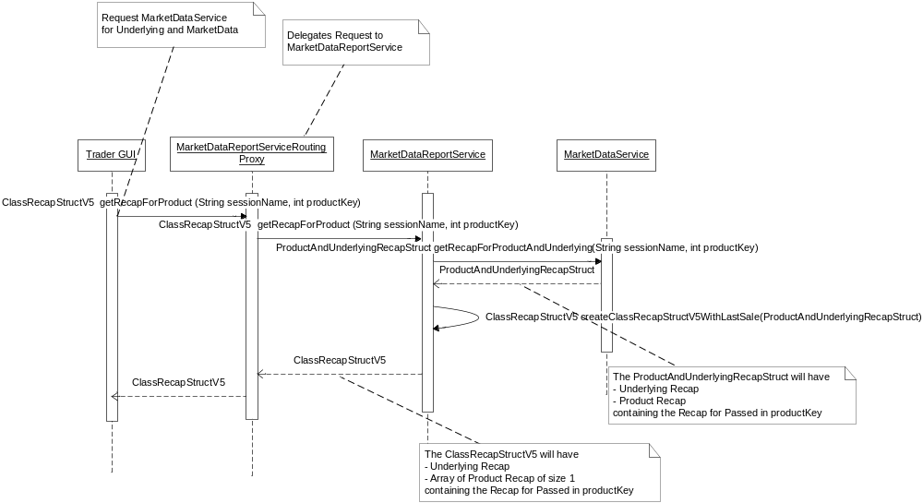

- GUI calls the method public getRecapForProduct of MarketDataReportServiceRoutingProxy.java (Front End) passing the sessionName and productKey.
- MarketDataReportServiceRoutingProxy delegates the request to the MarketDataReportService by calling the method getRecapForProduct of MarketDataReportServiceImpl.java.
- MarketDataReportService calls method getRecapForProductAndUnderlying of the MarketDataService for the market data information. This returns the ProductAndUnderlyingRecapStruct containing the Underlying Recap and Product Recap of passed in product key.
- Call method createClassRecapStructV5WithLastSale to create ClassRecapStructV5 from ProductAndUnderlyingRecapStruct fetched from MDS and overwrites the Last Sale information that it gets from cache.
- The ClassRecapStructV5 is retuned back to the caller. This struct contains the Underlying Recap and Array of Product Recap of size 1, containing the Product Recap of passed in product key.

- IDL Changes
To achieve the creation and transmission functionality following idl’s must be modified

MarketDataReportService.idl
Location – server/idl/MarketDataReportService.idl
Add operation called

cmiMarketData:: ClassRecapStructV5 getRecapForProduct (in cmiSession::TradingSessionName sessionName, in cmiProduct::ProductKey productKey)
raises(
exceptions::SystemException,
exceptions::CommunicationException,
exceptions::DataValidationException,
exceptions::AuthorizationException,
exceptions::NotFoundException
);

cmiMarketData.idl
Location – cmi/idl/cmiMarketData.idl
Add the following structs
struct RecapStructV5
{
RecapStruct recapStruct;
cmiUtil::DateTimeStruct lowPriceTime;
cmiUtil::DateTimeStruct highPriceTime;
cmiUtil::DateTimeStruct openingPriceTime;
};
typedef sequence <RecapStructV5> RecapStructV5Sequence;

struct ClassRecapStructV5
{
cmiMarketData :: RecapStructV5 underlyingRecap;
cmiMarketData :: RecapStructV5Sequence productRecaps;
};

struct ProductAndUnderlyingRecapStruct
{
RecapStruct underlyingRecap;
RecapStruct productRecaps;
};

MarketDataService.idl
Location - server/idl/MarketDataService.idl
Interface name - MarketDataService – Add an operation called

cmiMarketData::ProductAndUnderlyingRecapStruct getRecapForProductAndUnderlying(
in cmiSession::TradingSessionName sessionName,
in cmiProduct::ProductKey productKey)
raises(
exceptions::SystemException,
exceptions::CommunicationException,
exceptions::DataValidationException,
exceptions::AuthorizationException
);

3. Interfaces and Classes
Interfaces:
None
Classes:
FE Changes:
- com.cboe.proxy.businessServices. MarketDataReportServiceRoutingProxyHomeImpl.java
This class is the home for MarketDataReportServiceRoutingProxy.java.It will have the method for creation of instance of routing Proxy.Extends RoutingProxyHomeBase.java , Implements MarketDataReportServiceHome.java
- MarketDataReportService create()
  - Return instance of MarketDataReportService.
- MarketDataReportService find()
  - Returns MarketDataReportService instance. This method internally calls getProxyInstance() of RoutingProxyHomeBase.
- protected BusinessServiceRoutingProxy createRoutingProxy()
  - This method creates instance of MarketDataReportServiceRoutingProxy
- com.cboe.proxy.businessServices.marketDataReportService.MarketDataReportServiceRoutingProxy.java
This class extends the GlobalServiceRoutingProxy and implements the MarketDataReportService.
- ClassRecapStructV5 getRecapForProduct (String sessionName, int productKey)
  - Add new method to delegate call to public method getRecapForProduct of MarketDataReportServiceImpl.java
  - Return the ClassRecapStructV5 to the GUI.
- com.cboe. proxy.businessServices.marketDataReportService.MarketDataReportServiceProxy.java
- ClassRecapStructV5 getRecapForProduct (String sessionName, int productKey)
  - Add new method to delegate call to public method getRecapForProduct of MarketDataReportServiceImpl.java
BC Changes:
- com.cboe.businessServices.marketDataReportService.MarketDataReportServiceImpl.java
- ClassRecapStructV5 getRecapForProduct (String sessionName, int productKey)
  - Call method getRecapForProductAndUnderlying of MDS to get ProductAndUnderlyingRecapStruct for class
  - Call method createClassRecapStructV5WithLastSale to create ClassRecapStructV5 from ProductAndUnderlyingRecapStruct fetched from MDS and overwrites the Last Sale information that it gets from cache.
- ClassRecapStructV5 createClassRecapStructV5WithLastSale(ClassRecapStruct, RecapStructV5)
  - Combine RecapStructV5 and ClassRecapStruct and return the ClassRecapStructV5 to the FE.
- com.cboe.businessServices.marketDataService.MarketDataServiceRoutingProxy.java
- ProductAndUnderlyingRecapStruct getRecapForProductAndUnderlying(String sessionName, int productKey)
  - Delegate call to method getRecapForProductAndUnderlying of MarketDataService
- com.cboe.businessServices.marketDataService.MarketDataServiceImpl.java
- ProductAndUnderlyingRecapStruct getRecapForProductAndUnderlying(String sessionName, int productKey)
  - The ProductAndUnderlyingRecapStruct will have Underlying Recap and Product Recap for passed in productKey.

Logging
1. Informative messages will be logged at the beginning and end of each important method.

Exception Handling
1. All the exceptions will be propagated to the top level i.e. the method that is called from the ar command. This method will then log the exceptions (Log.exception) and return appropriate status from the method.

Scripts(2)
- None

Database(.5)
Changes in GC database
- RECAP_FOR_REPORTS table changes.
  - lowPriceTime
  - highPriceTime
  - openingPriceTime

SetContext(.125)
None

XML/DTD(.5)
1. v20Frontend.xml

Location: /vobs/dte/server/properties/xml/ v20Frontend.xml
- This xml will be modified for MarketDataReportServiceRoutingProxyHome

<BOContainer name="MarketDataReportServiceContainer">
<BOHome name="MarketDataReportServiceRoutingProxyHome">
<BOHomeProperties>
<homeImpl>com.cboe.proxy.businessServices.MarketDataReportServiceRoutingProxyHomeImpl</homeImpl>
<interceptorName>MarketDataReportServiceRoutingProxyInterceptor</interceptorName>
<interceptorImpl>com.cboe.proxy.businessServices.MarketDataReportServiceRoutingProxyInterceptor</interceptorImpl>
<poaName>FrontendPOA</poaName>
<objectId>MarketDataReportServiceRoutingProxyHome&lt;prefix&gt;Frontend</objectId>
</BOHomeProperties>
</BOHome>
</BOContainer>
- Adding the MarketDataReportServiceRoutingProxyHome in listOfHomes tag of
<FoundationFrameworkProperties>

Homes/Services(2)
- MarketDataReportingService
- MarketDataService

ImplPlan(.5)
None

PerformanceTestingProcedure(1)
None

TestingProcedure(1)
None

OperatorProcedure(.5)
None

Fallback/Failover
None

GUI Design

Appendix:
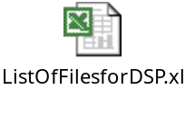

Queries
- The ClassRecapStructV5 returned to the GUI has a single productRecap. Do we write a new method like getClassRecap which would return single productRecap and the underlyingRecap in the ClassRecapStruct? This in place of the current call getRecapForClass which would return us all the productRecaps out of which we would need to discard all but the requested product information.
Ans 1: Create new method in Market Data Service like getRecapForProductandUndelying()...
Create new struct like ProductRecapStruct which will have the product data and underlying data
Trailing question – We do not need the new Struct, The ClassRecapStruct will have
- Underlying Recap
- Array of Product Recap of size 1 containing the Recap for Passed in productKey
This would be similar to what we return to the GUI from MDRS. (A ClassRecapStructV5 with underlyingRecap and the productRecap array of size 1 having single productRecap)
Do we also change the return parameter to GUI from ClassRecapStruct to some new struct like ProductAndUnderlyingRecap?

- What would be the source for the following?
  - Internal Last Sale Price
  - Internal Closing Price
  - Underlying Class Name
  - Underlying High Price for Day
  - Underlying Low Price for Day
  - Underlying Last Sale Price
Ans:
a. Internal Last Sale Price - Not required
b. Internal Closing Price - Not required
These will be from MDS underlying recap
- Since the lowPriceTime, highPriceTime, openingPriceTime would be cached by the MDRS we need the RECAP_FOR_REPORTS table to persist the values in event of failure.
Ans: Yes, These will be persisted

